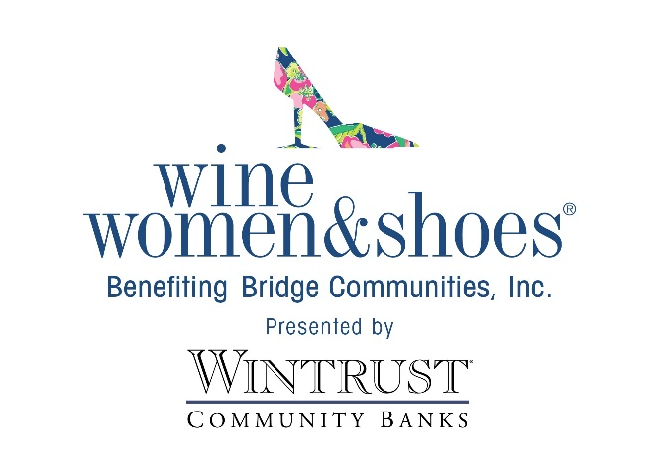
FOR IMMEDIATE RELEASE

DATE: December 18, 2023

CONTACT:
Andrew Baumann
Bridge Communities
Andrew.baumann@bridgecommunities.org

Bridge Communities Invites You to Kick Up Your Heels at Wine Women & Shoes Fundraiser
Oak Brook, Illinois – December 18, 2023 – Sip, strut and sparkle at the most glamorous soiree of the season! Bridge Communities will host its fourth annual Wine Women & Shoes event at the Oak Brook Hills Resort on Saturday, February 24, 2024 from 11 a.m. to 4 p.m.
With a goal to raise funds for families facing homelessness, Bridge Communities’ sip-sational event will feature delectable wine and bubbly tastings, a shoppable multi-designer marketplace, a savory lunch, exciting live and silent auctions, a fabulous fashion show by ZZAZZ Productions, a chance to win your dream closet, and much more.
A pour-fect blend of fashion, wine, and fabulous fun with your girlfriends, it is sure to be an event you won’t want to miss. Wine Women & Shoes is a fun-and-fashionable national event series that lets women put their most generous foot forward, sip to their hearts’ content, and laugh until their cheeks hurt.
Join us for an afternoon of dazzling delights. VIP and general admission tickets are now on sale. Proceeds from the event benefit the 100+ families facing homelessness served annually by Bridge Communities.
For more information, visit winewomenandshoes.com/bridgecommunities.
Bridge Communities is a non-profit 501(c)3 organization whose mission is to provide housing, mentoring and supportive services to families facing homelessness in DuPage County. Bridge Communities’ vision is a community where all families have safe, sustainable and affordable housing and life-long self-sufficiency. For more information, please visit www.bridgecommunities.org. Photos available upon request.

###

