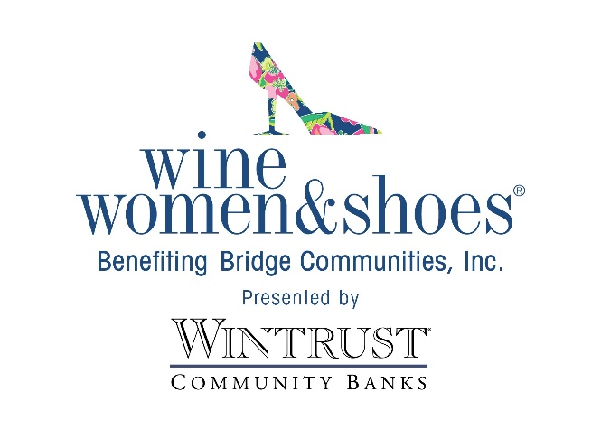
FOR IMMEDIATE RELEASE

DATE: January 23, 2025

CONTACT:
Andrew Baumann
Bridge Communities
Andrew.baumann@bridgecommunities.org

Bridge Communities Invites You to Step into Style at Wine Women & Shoes Fundraiser
Oak Brook, Illinois – January 28, 2025 – Sip, shop and savor the day at the most glamorous soiree of the season! Bridge Communities will host its fifth annual Wine Women & Shoes event at the Oak Brook Hills Resort on Saturday, March 8, 2025 from 11 a.m. to 4 p.m.
With a goal to raise funds for the 100+ families facing homelessness that Bridge Communities serves every year, this sip-sational event will feature delectable wine and bubbly tastings, a shoppable multi-designer marketplace, a savory lunch, exciting live and silent auctions, a fabulous fashion show by ZZAZZ Productions, a chance to win your dream closet, and much more.
The pour-fect blend of fashion, wine, and fun with your girlfriends, it is sure to be an event you won’t want to miss. Wine Women & Shoes is a national event series that lets women put their most generous foot forward, sip to their hearts’ content, and laugh until their cheeks hurt.
Join us for an afternoon of fashion and compassion. All tickets are now on sale. Proceeds from the event benefit the 100+ families facing homelessness served annually by Bridge Communities.
For more information, visit winewomenandshoes.com/bridgecommunities.
Bridge Communities is a non-profit 501(c)3 organization whose mission is to provide housing, mentoring and supportive services to families facing homelessness in DuPage County. Bridge Communities’ vision is a community where all families have safe, sustainable and affordable housing and life-long self-sufficiency. For more information, please visit www.bridgecommunities.org. Photos available upon request.

###

